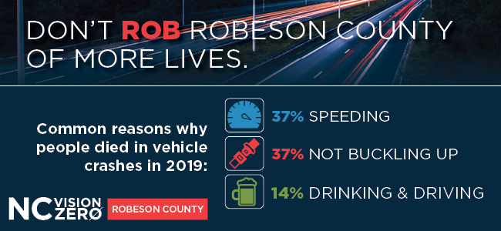

In 2018, community leaders formed the Robeson County Vision Zero task force which aims to have zero traffic deaths. Too many people in the county are dying because they are distracted, speeding, not buckling up or consuming alcohol.

The number of traffic deaths in the county declined for two straight years, but more people are dying in crashes in 2020. These deaths are preventable if we work together and change the driving culture in our community.

On average, 47 people die in vehicle crashes in Robeson County each year. Changing your behavior behind the wheel can save lives.

Do you know Robeson County ranks worst in North Carolina for total crashes?
In 2019, vehicle crashes claimed 43 lives – people who live, work or go to school in Robeson County.

Every year, about 47 people ⚰️ die in vehicle crashes in Robeson County – enough to fill two elementary school classrooms. Don’t become a 📉 statistic. @NC_GHSP @NCSHP

Help be part of the solution to. Learn how at ncvisionzero.org/robeson.

